**User Stories**   
   
 Pet Dating Online

Centennial College

 Nguyen Minh Tri - 301032649

Md Abdul Baten - 300871455

Anupreet Kaur Pannu - 301057802

Hyongdon Jeong - 301028026

Yerin An – 300947515

Mahbub Rahman - 300878062

05 October, 2019

Abstract

This written report in User Stories demonstrates on deep analysis about what specific activity for each role we came up with in the previous video. During the discussion, some roles were merged since we realized that they do the same activity with other roles.

1. **User Stories initiation**

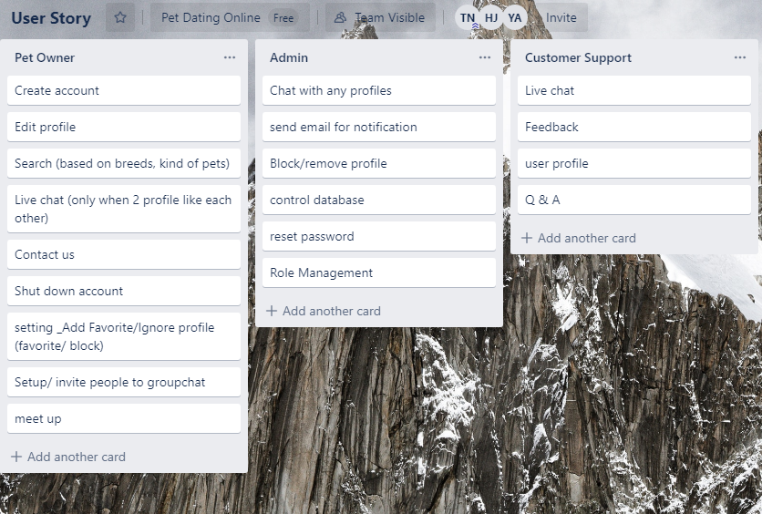

After we looked deeper into each user roles story, we decided to merge Pet Seeker, Pet Dater into Pet Owner and Technical Support into Customer Support role.

1. **User Stories**
   1. **Low-fidelity Prototypes**

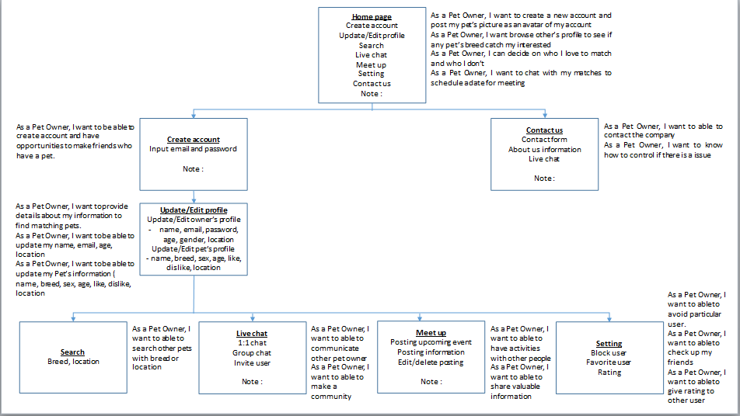

Figure 1. Low-fidelity prototype for Pet Owner

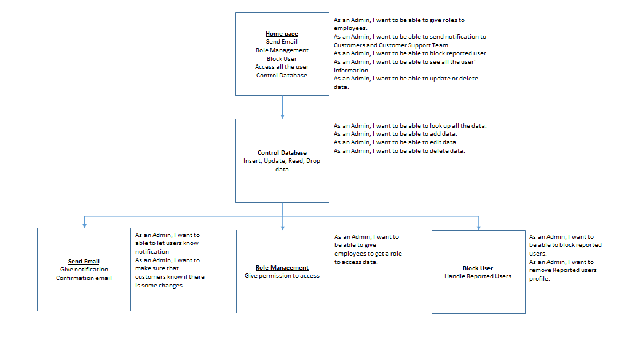

Figure 2. Low-fidelity prototype for Admin

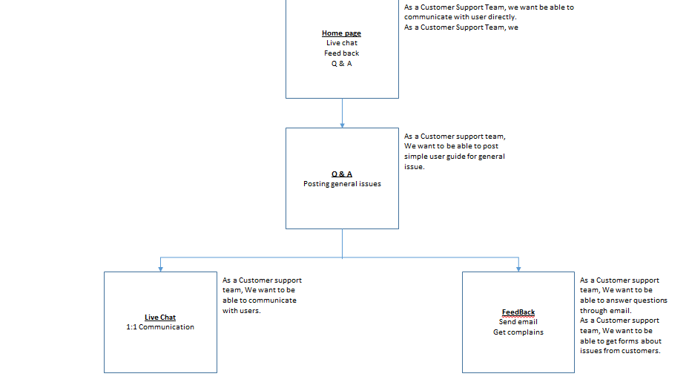

Figure 3. Low-fidelity prototype for Customer Support

* 1. **Story card** 
     1. **Pet Owner**

|  |  |  |
| --- | --- | --- |
| **Title**: Create account | **Priority**: High | **Estimate**: 6h |
| As a Pet Owner,  I want to create a new account and post my pet’s picture as an avatar of my account  So that my profile will be displayed to others with my favorite avatar | | |
| **Acceptance Criteria**  Given I have multiple picture  When I decide to upload all  Then My profile will display all the picture I uploaded as a “More picture” option | | |

|  |  |  |
| --- | --- | --- |
| **Title**: Search | **Priority**: High | **Estimate**: 6h |
| As a Pet Owner,  I want to browse other profile as a card  So that I can like/dislike the profile I browsed | | |
| **Acceptance Criteria**  Given there are more than profile that I like/dislike  When I browse to them and giving out like/dislike  Then the system store my selection for other features | | |

|  |  |  |
| --- | --- | --- |
| **Title**: Live chat | **Priority**: High | **Estimate**: 6h |
| As a Pet Owner,  I want to chat with my matched profile (both profile like each other)  So that I can schedule a meeting with them | | |
| **Acceptance Criteria**  Given I have multiple matches  When I want to choose some particular profile to chat with  Then The system will display a list of my matched profile for me to choose who to chat with and store chatting history | | |

|  |  |  |
| --- | --- | --- |
| **Title**: Live chat | **Priority**: High | **Estimate**: 6h |
| As a Pet Owner,  I want to create a group chat with some of my matches  So that I can start chatting with them in group | | |
| **Acceptance Criteria**  Given I already create a new group chat  When I want to add more people to the group or remove people that are already inside the group chat  Then the system will show the list of participations with the options to do that | | |

|  |  |  |
| --- | --- | --- |
| **Title**: Notification | **Priority**: High | **Estimate**: 6h |
| As a Pet Owner,  I want to receive a notification  So that I can know if I have new message or new matches | | |
| **Acceptance Criteria**  Given I want to manage my notification alert  When I go to my profile page setting  Then I can change how I receive the notification | | |

|  |  |  |
| --- | --- | --- |
| **Title**: Contact Us | **Priority**: Low | **Estimate**: 2h |
| As a Pet Owner,  I want to contact with the management team (admin, customer support)  So that I can report a bug or suggest new features that seems convenience for me | | |
| **Acceptance Criteria** | | |

|  |  |  |
| --- | --- | --- |
| **Title**: Meet up | **Priority**: Medium | **Estimate**: 3h |
| As a Pet Owner,  I want to create a new meeting event with some people  So that I can remind them for our upcoming meeting | | |
| **Acceptance Criteria**  Given I have more than one people that are interested in meeting each other  When I want to set a reminder for a meeting and send notification to the people involved  Then the system will allow me to create a new meet up event and enable me to add multiple people for one event | | |

|  |  |  |
| --- | --- | --- |
| **Title**: Edit/ Delete a Meet up | **Priority**: Medium | **Estimate**: 2h |
| As a Pet Owner,  I want to edit the existing meet up that I created  So that I can change the meeting time or providing information to others | | |
| **Acceptance Criteria**  Given I want to make change to the event that have already been edited recently  When I edit the event again  Then the system will update the latest change that I made for that particular event | | |

|  |  |  |
| --- | --- | --- |
| **Title**: Settings | **Priority**: Low | **Estimate**: 4h |
| As a Pet Owner,  I want to add a matched profile as my favorite  So that the starred profile will always show up at the top of my matches list | | |
| **Acceptance Criteria**  Given I have multiple favorite profile  When I want to set all of my favorite profiles as starred profiles  Then the system will allow me to do so and display all of my starred profile ordered by who I picked first | | |

|  |  |  |
| --- | --- | --- |
| **Title**: Setting | **Priority**: Low | **Estimate**: 3h |
| As a Pet Owner,  I want to block someone that I feel uncomfortable with  So that they can no longer chat with me | | |
| **Acceptance Criteria**  Given I want to unblock some of my blocked profiles  When I unblock a profile  Then that profile can start a conversation with me again | | |

|  |  |  |
| --- | --- | --- |
| **Title**: Setting | **Priority**: Low | **Estimate**: 3h |
| As a Pet Owner,  I want to rate my matches  So that they will become more prominent in the search result | | |
| **Acceptance Criteria** | | |

* + 1. **Admin**

|  |  |  |
| --- | --- | --- |
| **Title**: Login | **Priority**: High | E**s**timate: 2h |
| As an Admin,  I want to login to the system as an administrator  So that I can manage the application | | |
| **Acceptance Criteria** | | |

|  |  |  |
| --- | --- | --- |
| **Title**: Role Management | **Priority**: Medium | **Estimate**: 1h |
| As an Admin,  I want to set a role to a specific user (customer support)  So that I can extend the management team size | | |
| **Acceptance Criteria**  Given I want to unset an account back to normal user  When I access to the management role list  Then the system will display a list of management team and I can make a change there | | |

|  |  |  |
| --- | --- | --- |
| **Title**: Block User | **Priority**: Medium | **Estimate**: 2h |
| As an Admin,  I want to be able to block any user.  So that I can avoid them from using the system for a period of time | | |
| **Acceptance Criteria**  Given I want to unblock an account  When I access to the blocked user list  Then the system will display a list of blocked users and I can unblock anyone | | |

|  |  |  |
| --- | --- | --- |
| **Title**: Access to profile | **Priority**: Medium | **Estimate**: 2h |
| As an Admin,  I want to access to any information in a profile  So that I can see if they are a bot account or not | | |
| **Acceptance Criteria** | | |

|  |  |  |
| --- | --- | --- |
| **Title**: DB Access | **Priority**: High | **Estimate**: 2h |
| As an Admin,  I want to be able to access to the DB to see all the user  So that I can see full list of users who registered | | |
| **Acceptance Criteria**  Given I want to make changes to the DB  When I access to the DB with administrative credential  Then the system will allow me to do CRUD to the database | | |

|  |  |  |
| --- | --- | --- |
| **Title**: Send email | **Priority**: Medium | **Estimate**: 2h |
| As an Admin,  I want send a notification email to all users  So that I can remind them or notify about some events | | |
| **Acceptance Criteria**  Given I want to send email to specific users  When I specify the users that I want to send email  Then an email will be sent to only my selected recipients. | | |

* + 1. **Customer Support**

|  |  |  |
| --- | --- | --- |
| **Title**: Login | **Priority**: High | **Estimate**: 2h |
| As an Customer support,  I want to login to the system with features as a customer service  So that I can play my role as a customer service | | |
| **Acceptance Criteria** | | |

|  |  |  |
| --- | --- | --- |
| **Title**: Live chat | **Priority**: Medium | **Estimate**: 2h |
| As an Customer support,  I want start a live chat with any profiles I want  So that I can respond to their feedback | | |
| **Acceptance Criteria** | | |

|  |  |  |
| --- | --- | --- |
| **Title**: Receive feedback | **Priority**: Medium | **Estimate**: 2h |
| As an Customer support,  I want to receive all the feedback of users  So that I can take note and respond to them | | |
| **Acceptance Criteria** | | |

1. **User Stories Estimated Hours and Prioritized**

### Summary of estimated stories using the Wideband Delphi approach and Prioritized stories using the MoSCoW rule.

|  |  |  |
| --- | --- | --- |
| **User Story** | **Estimate** | **Priority** |
| As a Pet Owner, I want to create a new account and post my pet’s picture as an avatar of my account | 6h | High |
| As a Pet Owner, I want to browse other profile as a card | 6h | High |
| As a Pet Owner, I want to chat with my matched profile (both profile like each other) | 6h | High |
| As a Pet Owner, I want to create a group chat with some of my matches | 6h | High |
| As a Pet Owner, I want to receive a notification | 6h | High |
| As a Pet Owner,I want to contact with the management team (admin, customer support) | 2h | Low |
| As a Pet Owner, I want to create a new meeting event with some people | 3h | Medium |
| As a Pet Owner, I want to contact with the management team (admin, customer support) | 2h | Low |
| As a Pet Owner, I want to add a matched profile as my favorite | 4h | Low |
| As a Pet Owner, I want to edit the existing meet up that I created | 2h | Medium |
| As a Pet Owner, I want to block someone that I feel uncomfortable with | 3h | Low |
| As a Pet Owner, I want to rate my matches | 3h | Low |
| As an Admin, I want to login to the system as an administrator | 2h | High |
| As an Admin, I want to set a role to a specific user (customer support) | 1h | Medium |
| As an Admin, I want to be able to block any user. | 2h | Medium |
| As an Admin, I want to access to any information in a profile | 2h | Medium |
| As an Admin, I want to be able to access to the DB to see all the user | 2h | High |
| As an Admin, I want send a notification email to all users | 2h | Medium |
| As an Customer support, I want to login to the system with features as a customer service | 2h | High |
| As an Customer support, I want start a live chat with any profiles I want | 2h | Medium |
| As an Customer support,  I want to receive all the feedback of users | 2h | Medium |

**Reference**

1. Cohn, Mike. 2004. User Stories Applied: For Agile Software Development, Addison-Wesley Professional.